**Materials Data Curation System:**

**Setup instructions for Windows**

1. Download and install MongoDB 3.x from <https://www.mongodb.org/downloads>
2. Double-click on setup.exe.

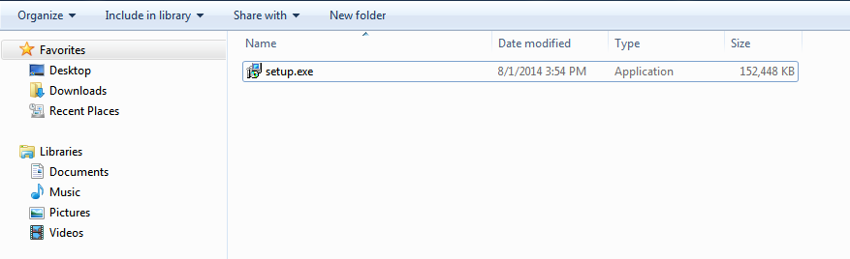

1. A pop-up asking for administrator access will appear. Allow the program to run on your computer by typing your username and password and click on ‘Yes’, or simply by clicking on ‘Allow’.
2. Use the setup assistant to install the program. Go to the next step using the ‘Next’ button.

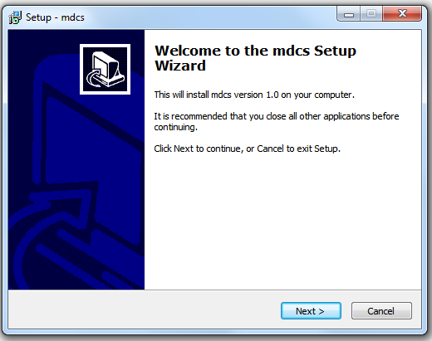

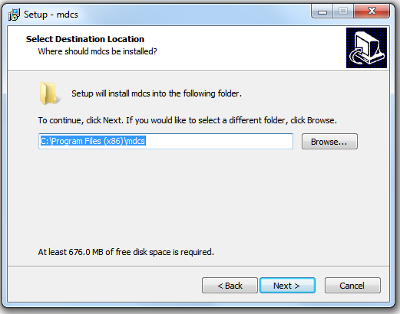

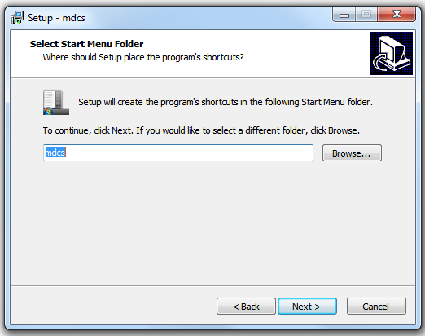

1. Then click on the ‘Install’ button to start the installation.

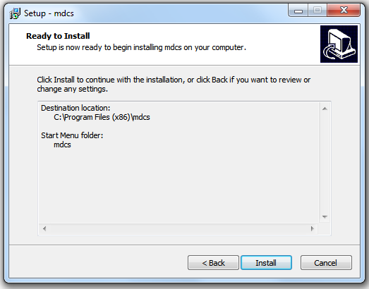

1. Wait for the installation process to finish.

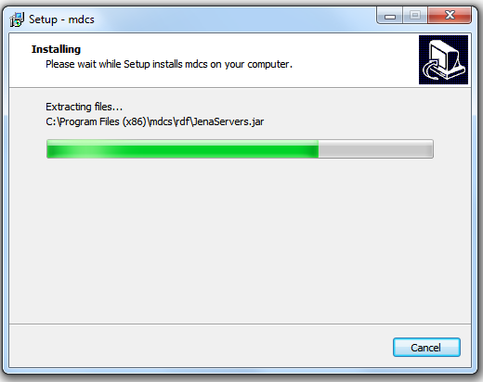

1. Click on Finish to close the setup assistant.

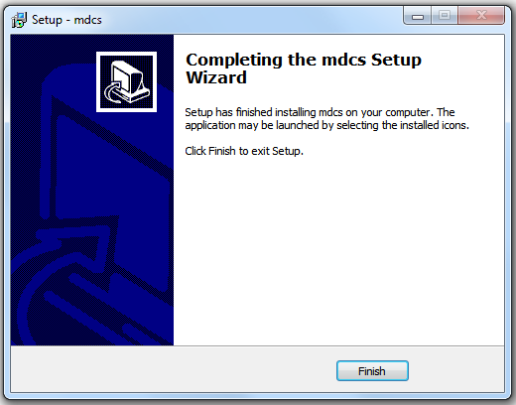

1. The program is now well installed on the computer and a shortcut is created on the desktop.

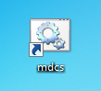

1. To run mdcs, you have to run it as an administrator. Right-click on the mdcs shortcut on the desktop and select ‘Run as administrator’. A pop-up asking for administrator access will appear again. Allow the mdcs to run on your computer by typing your username and password and click on ‘Yes’, or simply by clicking on ‘Allow’.

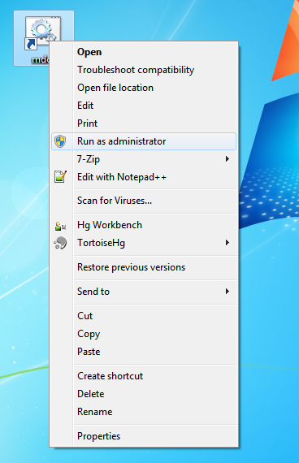

1. Once the program is running the three following Windows should appear. Let them open to let mdcs running well.

